
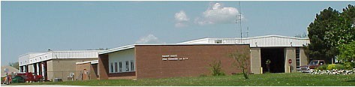
1250 South M-33
Ogemaw
P.O. Box 157
County West Branch, Michigan 48661
Phone | (989) 345-0234
Fax | (989) 345-2337
Web | www.OgemawCRC.org | Email | OCRC@OgemawCRC.org

Road
Commission & Board of Public Works

Notice of Public Hearing

The 7D Task Force Regional Meeting will meet at 10:00 a.m. on Monday, October 21, 2024, at the offices of the Roscommon County Road Commission, 820 E. West Branch Road, Prudenville, MI, 48651, for the purpose of reviewing the expenditures of Federal and State Transportation Improvement Program-Rural (STL) and Transportation Economic Development Fund (Category D) funds for fiscal years 2025, and a call for projects in the years 2026-2029 to be included in the Statewide Transportation Improvement Program (STIP). Interested individuals may attend the public meeting. Those with special needs may contact the Road Commission at 989-366-0333.

MANAGER | CHAIRMAN | COMMISSIONER | COMMISSIONER
Pat Reinke | Dan Winter | Van Sheltrown | Klint Marshall

